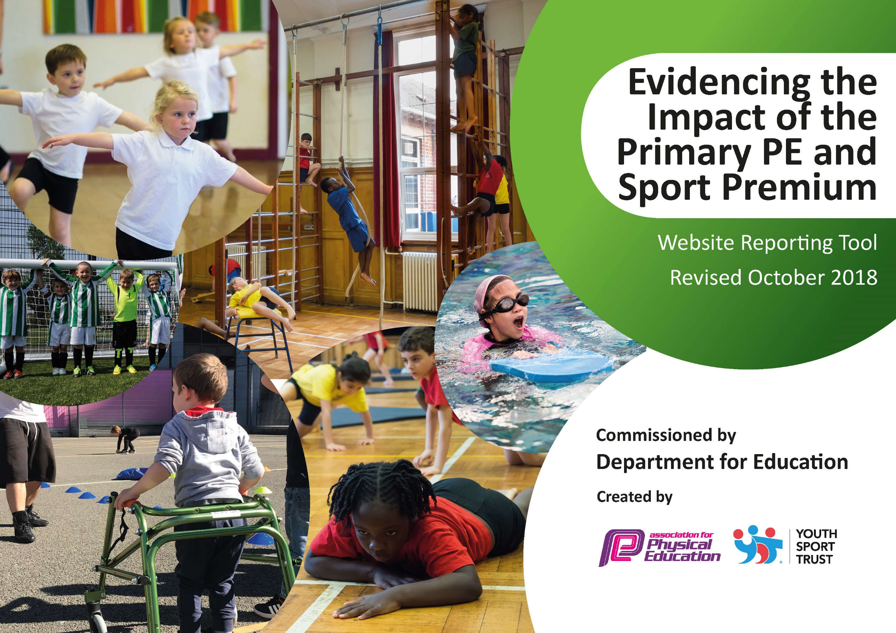
Silchester C of E Primary School
Updated 24-25

Meeting national curriculum requirements for swimming and water safety | Please complete all of the below:
What percentage of your current Year 6 cohort swim competently, confidently and proficiently over a distance of at least 25 metres?  N.B. Even though your children may swim in another year please report on their attainment on leaving  primary school. | 100%
What percentage of your current Year 6 cohort use a range of strokes effectively [for example, front crawl, backstroke and breaststroke]? | 97%
What percentage of your current Year 6 cohort perform safe self-rescue in different water-based situations? | 91%
Schools can choose to use the Primary PE and Sport Premium to provide additional provision for swimming but this must be for activity over and above the national curriculum requirements. Have you used it in this way? | NO
Data collected from % of children who had returned to Yr6 in Autumn 2024

Silchester C of E Primary School
Sports and PE Offer

Vision

- All pupils will leave Silchester C of E Primary School Physically Literate with the knowledge skills and motivation to equip themselves with a healthy life style and life long participation in sport and physical activity.

Aim
- To achieve self-sustaining improvement in the quality of PE and Sport in our school

Objectives
- To increase participation in physical activity across the school, in lessons, break times and after school.
- Raise the profile of sport and pe so it is a valued, respected and enjoyed component of our curriculum offer
- Increase the confidence, subject knowledge and pedagogic knowledge of our teaching staff.
- Provide a range of broad experiences to all of our pupils
- Increase the schools participation in competitive Sport

Academic Year: 2024/2025 | Total fund allocated: | Date Updated: 16/9/24
Key objective 1: Increase physical participation of pupils during both taught lessons and break times |  |  |  | Percentage of total allocation:
 |  |  |  | 34%
School focus with clarity on intended impact on pupils: | Actions to achieve: | Funding allocated: £6050 | Evidence and impact: | Sustainability and suggested next steps:
Develop/increase children’s general fitness levels in curriculum and in free time such as playtimes and lunch breaks.  . | Further develop activities on the long term PE plan in order to broaden the children’s sports and physical experiences, skills and knowledge.  To include PE/Sport activity in our schools Wow weeks (Quiddicth Match)  To take part in all national and international Sporting days  Ensure suitable equipment (regularly monitored) is available for different PE games and lunchtime activities  Appoint lunchtime supervisor to organise games and activities through the use of sports leaders at break time  Continue to ensure a good range of Sports Clubs are on offer to all children | 2 x days PE Leader Release  £500 to hire coaches or buy equipment  PE leader Release Tim  £750 Lunch Equipment  £1500 PE equipment  7.5 hours a week x 39 weeks a year  Resource internally/pay for external | - Increased up take in sporting clubs  - Increased participation in games and activities at lunchtime/break time  - Increased enjoyment of taking part in sporting activities

Key objective 2: The profile of PE raised across the school |  |  |  | Percentage of total allocation:
 |  |  |  | 20%
School focus with clarity on intended impact on pupils: | Actions to achieve: | Funding allocated:  £3600 | Evidence and impact: | Sustainability and suggested next steps:
Sports Lead role created – to manage sports funding, promote sports and healthy lifestyles, to increase school sports and participation in competitive events.  Increase the status and pride of taken part in sporting activities for our school  Emphasise the importance of PE to healthy lifestyles both Physical and mental health  . | Appoint dedicated member of staff. Provide regular time out of class to develop and maintain the provision.  Provide access to Silchester sports kits for children and staff.  Introduce reward system for sporting excellence and participation.  Create roles and responsibilities for children to undertake related to PE  Sports competitions and tournaments are celebrated in Achievement assembly and through the schools fortnightly newsletter.  Review PSHE and Science Curriculum. Introduce Golden Thread of How to look after ourselves  Celebrate Mental Health Week with guest speakers | £2,200 (10 days Release time over the year)  £200  Sports Coaches  £500  £400  NA  NA  £300 | All stakeholders show increased value to the importance of sport through surveys.  More children are taking part in a wider range of sporting activities  The school develops a culture of striving for and achieving sporting excellence with regards to participation and progress.

Key Objective 3: Increased confidence, knowledge and skills of all staff in teaching PE and sport |  |  |  | Percentage of total allocation:
 |  |  |  | 19%
School focus with clarity on intended  impact on pupils: | Actions to achieve: | Funding  allocated: £3,350 | Evidence and impact: | Sustainability and suggested  next steps:
Develop outstanding Leadership in PE  Provide expert coaching to staff.  Support with planning sequences of lessons | Take part in Collaboration PE training that has been commissioned through the HIAS PE TEAM. This will include Theory, strategy and subject knowledge training.  Develop the consistent and accurate use of LOs and SC in PE – clear focus on skills being developed.  Maintain and continue to improve quality of PE teaching and learning for all teachers to benefit pupils.  Improve teachers ability to assess and adapt learning by having strong subject knowledge | Teacher Training  £2500  Including Subject Training  PE Lead release time  6 days across the year  PE lead to develop system and train staff during release time | Lesson monitoring shows highly competent teachers delivering higjly effective lessons  Assessment shows that all pupils regardless of background are making good progress  Planning displays strong subject and pedagogic knowledge.

Key objective 4: Provide Broader experience of a range of sports and activities offered to all pupils |  |  |  |  | Percentage of total allocation:
 |  |  |  |  | 17%%
School focus with clarity on intended  impact on pupils: | Actions to achieve: |  | Funding  allocated: £3000 | Evidence and impact: | Sustainability and suggested  next steps:
Increase the number of children getting involved in an increased range of sporting activities. | Join the Basingstoke and Deane sporting partnership and sign up for all competitive and non-competitive sporting events.  Through clubs and the planned curriculum, the children have access to a wide range of different sports that have a competitive element.  Relax Kids provided for targeted groups led by external agency to promote mental health and wellbeing.  Range of coaches to lead assemblies and coaching sessions to broaden children’s experiences  Celebrate and promote international sporting events throughout the year. |  | £500  Relax Kids  £600  Up to £2000  Release Time PE Lead | Increased number of children participating in competitive and non-competitive sporting events.  Wider range of sports being undertaken at Break times  Evidence in newsletters and displays of the i  importance of sport.
Key indicator 5: Increased participation in competitive sport |  |  |  |  | Percentage of total allocation:
 |  |  |  |  | 11%
School focus with clarity on intended  impact on pupils: | Actions to achieve: | Funding  allocated: £2,000 |  | Evidence and impact: | Sustainability and suggested  next steps:
Increase the number and range of events that the school is involved with at district, Cluster and Partnership Level | join B&D sports Partnership  Meet with Cluster PE leads to arrange events  Meet with Partnership PE leaders to arrange events  PE leader to plan events throughout the year and encourage other staff to lead them | Sports Partnership  £500  Transport  £100 per year  Staff Release  £1500 |  | Greater number of events entered  Greater number of children participating  Increased numbers of vulnerable children taking part in competitive sport.
Allocation: £17,628 Planned Spending: £18,150 Actual Spend:

